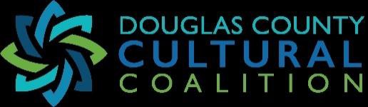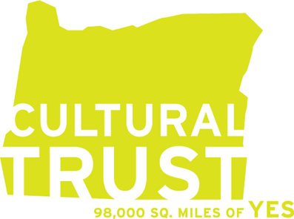

Double the Impact of Your Gift

Douglas County Cultural Coalition Grant Announcement for FY 2026

Grants for arts and cultural organizations range from $1,000 to $3,000. Eligible activities include operational expenses or special projects.

We are looking for cultural partners with a history of providing programming and services. To be eligible for funding, you must provide services solely benefitting Douglas County residents.

Applications are due February 28, 2026 by 5 pm. Submit your responses to the questions below to douglascountycc@gmail.com Awards will be announced via email by mid-March. All grantees will be required to submit a final report at the end of year. Any past grantee whose reports have previously been late or delinquent will not be eligible for funding.

Please include the name of your organization, primary contact and a telephone number in case we need to contact you. Incomplete applications will not be considered.

What is your organization or group name?

What is your address? (Address, City, State, ZIP)

What is your email address?

What is your website? (Optional)

What amount are you requesting? You may request up to $3,000 if you are an organization or $1,000 for an individual as long as the project has cultural or artistic merit benefitting Douglas County residents.

Are you (select one):
A 501(c)3 organization
An organization that relies on a fiscal sponsorship to receive funds
None of the above

- Applicant/Organization Information. Tell us a little bit about your organization and its mission or services. (100 words or less)

- Select the category that most closely matches your work:
Performing Arts (music, theatre, dance, circus, etc.)
___ Cultural Heritage (ways of living developed by a community and passed on) or Humanities
___ Literary Arts (poetry, prose, spoken word, etc.)
___ Community Events (celebration, block party, festival, etc.)
___ Visual Art (painting, ceramics, weaving, printmaking, sculpture, etc.) or Media Arts (film,
video, photography, VR, interactive media, etc.)

- Project Summary. Please provide a brief one- or two-sentence description of your project/program/event, capacity building, capital project, or general operating need.

- Select the category that most closely matches your use of funds:
project/program/event
___ capacity building
___ capital or special project
___ operating needs

- Project Description. Tell us about your project or activity. Provide enough information to assist the committee clearly understanding your project. (250 words or less)
Please include the following:
  - Who and what is involved
  - When and where it will take place
  - Project timeline, even if dates are estimates. (Funds must be expended by December 31, 2026)

Select which DCCC goal(s) that your proposal meets and explain how it achieves this goal. (250 words or less)
- Fosters expression and access of the arts, heritage and humanities
- Encourages and engages youth in the arts, heritage and humanities
- Coordinates, disseminates and promotes arts, heritage and humanities

Douglas County support depends upon support from the Oregon Cultural Trust (OCT). The OCT raises funding from matching gift tax credits, license plate sales and other philanthropic partnerships, and depends on local individuals and organizations to promote and support donations to the Oregon Cultural Trust. Please outline your organization’s plan for promoting and educating your members, donors, and volunteers about the benefits of contributing to the OCT. Activities can include inviting OCT representatives to a board meeting or events, distributing materials in annual mailings, including information on your website or social media. (100 words or less.)

8. Please share your project budget showing how DCCC funds will be used. Please state other potential sources of income/support, if any, for your project. Add more lines if needed.

Revenue: Itemized estimate of project-related revenue sources.
Include a general list of revenues showing that you seek funding sources outside of DCCC to help support your project. This could be other grants, contributions from local businesses, sponsorship, or in-kind donations, or self-funding.

Contribution / Revenue Source Description | Amount | Secured or Pending

TOTAL:

Expenses: Itemized estimate of project-related costs/budget:
Include a general budget showing you have considered as many costs as possible and that
you can keep your project within budget. Should include your project’s relevant expenses.

Budget Item Description | Amount

TOTAL:

9. Please list previous funding from the Douglas County Cultural Coalition, including the amount, date and purpose.

